**Sequence, Selection and Iteration**

Sequence is when instructions are executed one after the other.

An example of this is a calculation – each part of the calculation could be a separate statement.

A code sample is as follows:

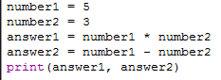

This code assigns some variables, does some calculations and assigns the results to variables, and prints the variables. Each statement is executed in order, and the program will run in sequence until the last instruction is complete.

When instructions need to be completed in different orders depending on the situation, selection is used instead.

Selection statements allow the computer to make a decision based on conditions.

Examples of this include if/else statements, and try/except statements.

Conditions can include user input, variables, and previous events in the program.

A example of selection in code would be as follows:

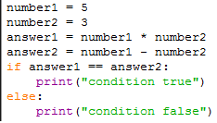

The output of the program is selected by the if/else statement. As it satnds, the program should output ‘condition false’, but if number1 and number2 were changed to 2 and 1 respectively, then the program would output ‘condition true’.

Iteration is used when the same instruction needs to be repeated many times, particularly when the number of repeats depends upon a condition.

For loops will repeat blocks of code for a certain condition – such as a variable being less than the length of a list.

While loops will repeat a block of code while a condition is true – like an if statement but with repetition.

A code sample is as follows:

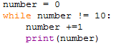

This simple code prints the numbers 1 to 10 with a while loop. Which will repeat the code nested inside it (increase number by 1, print number) until a condition is met – in this case, that number is equal to 10.